The Important Thing about Pajamas

Read: – The Important Book by Margaret Wise Brown

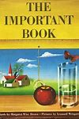
(CTRL + Click on the image to hear the story)

Literacy:

It’s pajama day!! Grab your stuffy and stay in your pajamas. Cuddle up and enjoy listening to the book The Important Book by Margaret Wise Brown. Listen to all the important things about everyday items…it may not be the function you were thinking. Feel free to pause the book to talk with your family about each item. Once the book is finished, try to come up with some thoughts about what is the most important thing about Pajamas to you. Talk with your family and see what the most important thing about pajamas are to them. Compare your ideas. In a journal or on a piece of paper, try do the entry below. You could copy the sentence starters, and then try to finish the sentence using the sounds you hear in the words.

Note to parents:
Remember it is perfectly okay for Kindergarten children to use invented spelling. Help them stretch out the words and print the sounds they hear. Don’t correct their spelling too much. The idea is for your child to ENJOY using what they know about letter sounds. It is not expected that they spell words conventionally in Kindergarten. Show them that you can read their words even if they are not spelled correctly. Celebrate their progress so that they want to keep trying. Too much correction at this stage is discouraging.

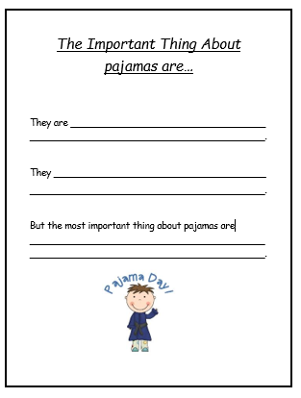

Numeracy:

Trace one of the pajamas below into your journal, or just draw your own set of pajamas. Try to create an AB or ABC pattern on your pajamas. Remember, an AB or ABC pattern needs to repeat.

Questions you can ask your child:
Compare your pajamas to my pajamas. What is the same/different?
Compare your sleeve length to mine? What could we use to measure our sleeves? (How many spoons (lego pieces, DVD movie cases, etc…) long is your sleeve?)
Do your/my pajamas have a pattern?
What other patterns can you see around your house?

Lesson Extensions:
Talk about your bedtime routine. Draw pictures to represent each part of your routine, to sequence the activities…or, parents you can draw the sequence of events, cut them apart and have your child sequence them in the right order and orally tell the story of their bedtime routine.

Daily Physical Activity: Tommy the Bedtime Turtle – Cosmic Kids Yoga
Extras:
Video - Goodnight Corduroy https://www.youtube.com/watch?v=5OW2urUFmnI

Story - Pajama Day by Robert Munsch https://www.youtube.com/watch?v=lmYjC0IdY9g

