Giant Easter Egg Creation and Hunt

In this lesson students will enjoy a story, create an art project, write words of hope and encouragement and then go on a community scavenger hunt.

Read: – The Biggest Easter Basket Ever by Steven Kroll Illustrated by Jeni Bassett

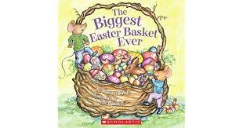
Reading: Easter is almost here and we are getting so excited to celebrate. Enjoy listening to The Biggest Easter Basket Ever by Steven Kroll Illustrated by Jeni Bassett.
https://www.youtube.com/watch?v=i-Z7GQDu0xE

Art and Writing:

Materials:
- White paper
- Masking tape or green painters tape
- Sidewalk chalk, crayons, or whatever you have to color in the spaces

Directions: You will be creating an Easter Egg
- Draw and cut out an Easter egg shape using as much of the paper as possible.

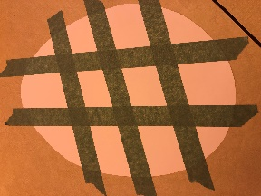
- Use masking tape or green painters tape to make a design on your egg. Remember the smaller the spaces you make, the more you will have to color. I suggest leaving no more than 15 spaces.

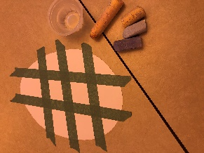
- If you have sidewalk chalk try dipping it in water to create a really cool texture. Other options for color are crayons, pencil crayons, markers or paint. Whatever you have will work perfectly.

- After all spaces are colored in, carefully peel the tape off your paper.
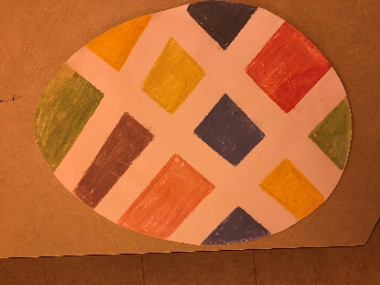
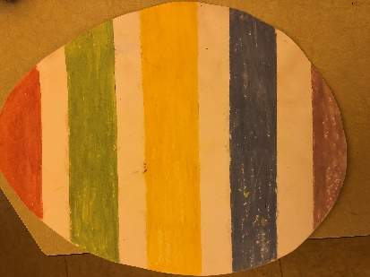

- Tada, you have a beautiful colorful giant egg!
- Once your egg is dry use the use the white space to write some words of encouragement to show support to your neighbors in this difficult and scary time. Talk with your child about the message you would like to send to others in your neighborhood.
  - Some ideas may be courage, support, love, kindness, hope
    - Note to parents: Remember it is perfectly okay for Kindergarten children to use invented spelling. Help them stretch out the words and print the sounds they hear. Don’t correct their spelling too much. The idea is for your child to ENJOY using what they know about letter sounds. It is not expected that they spell words conventionally in Kindergarten. Show them that you can read their words even if they are not spelled correctly. Celebrate their progress so that they want to keep trying. Too much correction at this stage is discouraging.
- Once your egg is complete, hang it in your front window or on your front door so it is visible for your neighbors to enjoy.

Numeracy challenge:
Now that we all have beautiful eggs with encouraging words hung up around our neighborhoods, make yourself a tally chart something like this on a piece of paper or in your journal/notebook:

Easter Eggs found in Windows | Animals | Flowers Growing | Smile or wave at Someone

Go walk around your neighborhood and put a tally under each section. See how many tallies you can get for each item and then write that number in the bottom box.

Extension Activities:

Easter Egg Number Match: Hide the pieces of plastic eggs around you house (you could also make egg shapes out of paper and cut them in half if you don’t have plastic eggs). Have children find all the pieces and make the matches.

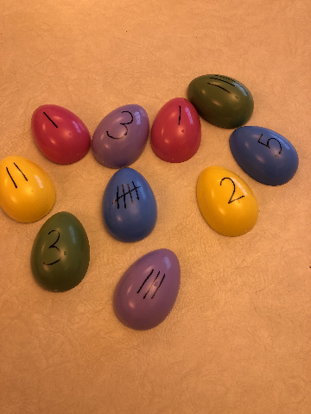

You could also complete this activity with uppercase letters on one side and lowercase letters on the other to do a letter search and match. Have fun with it!

Sight Word or Alphabet Egg Hunt:
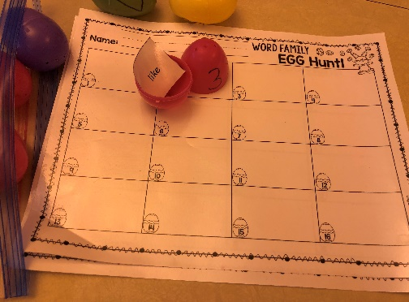
- Number the outside of the egg with as many letters or words that you want to hide.
- Put uppercase letters, lowercase letters, or sight words inside an egg.
- Hide the eggs and the children hunt for them, open them, and write beside the number they found the letter or the word that was inside.
- Happy hunting!

Other Fun Activities:

Story for Enjoyment: There was an Old Lady Who Swallowed a Chick by Lucille Colandro Illustrated by Jared Lee

https://www.youtube.com/watch?v=1jD-8qRjvzM
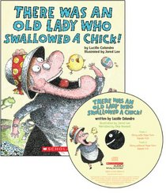
￼
Video: Peep and The Big Wide World: The Mystery of the Thing that Went and Came Back - https://www.youtube.com/watch?v=cf5wool6r2c

Discussion questions to ask about the video:
Are Quack and Peep following the group plan?
What shape is the pink item that Peep found?
Why did the egg not roll in a straight line?
Pause the video at any time and ask what do you think might happen next?
How does Peep show he is a good friend?
Who took the big piece of the egg?
Why do Peep’s legs feel funny? Have you ever done something for a very long time and then your legs feel funny afterwards? What did you do?

