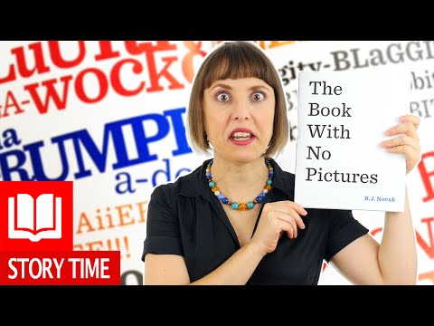
The Book With No Pictures
Each year, students in my class fall in love with this goofy book! It’s true that it doesn’t have any pictures, but the adult who reads it must say ridiculous things. While laughing, students are also practicing their skills of sharing a topic, building vocabulary, enriching language skills like predicting and questioning, and sparking creativity and imagination. Just as importantly, this book fosters the love of reading – a skill that pays off big time in the future!
Watch a video of B.J. Novak’s “The Book With No Pictures”
Hold Ctrl and click over the book cover!

- Talk about the book. Here are some conversation starters if you’d like:
- Which page is your favorite? Why?
- If you wrote a book, what would you like it to say?
- I wonder if there is a book with too many pictures? How would that work?

- Think about “sparkle” words or vocabulary you enjoyed or haven’t heard often from the book.
Look at some of the cool words below.
Find each word in the book. Does someone in your family know what it means?
- entire - preposterous
- ridiculous - serious

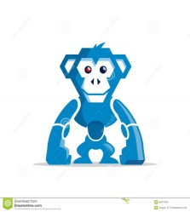
- Write down a word that you make up. Try to make it super silly – just like in the book. Ask someone in your family to read it out loud. Does it make you laugh? You can make up ridiculous things for everyone in your family to have to say if you’d like.

- Draw. Choose one or more of the words below and become an “illustrator!” That means you get to decide what these preposterous things might look like! Try to use as many colors as your age. (Eg. If you’re 6, use 6 colors or more.)
- Ba-dooongy face - Blork
- Ma-grumph-a-doo - Bluurf

- Move: Hold Ctrl and click the monkey picture to check out a “5 Little Monkeys”
song/dance done “robot style!”

- Craft fun: Hold Ctrl and click the hippo below to make Boo Boo Butt, Robot Monkey, or
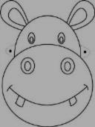
Blueberry Pizza Head masks!

- Math Challenge: Can you figure out these math word problems?
- 5 Robot Monkeys are jumping on your bed. 2 fall off. One of them crawls back onto your bed. How many monkeys are on your bed now?

- Say” Boo Boo Butt” 3 times in a row. How many Bb words did you say altogether?

- Your Blueberry Pizza Head has 8 slices. Somebody ate 2 of them! How many are left?

